Magic Ratios for Genetics:
(a.k.a. a very “corny” lab)

This lab explores the relationship between phenotypes and genotypes in mendelian genetics, and teaches you how to do a punnett square. You will also learn to do a chi squared analysis

Using Punnett Squares to Predict Phenotypic Ratios

Fill out these punnett squares and use your answers to complete punnett squares and make predictions for the phenotypic ratios of the offspring you would expect to see from such a cross. For these first few exercises, dominant will be black and recessive will be white. You will sometimes be asked to treat the gene as if it has complete dominance, and sometimes as if it has incomplete dominance.

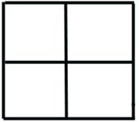
1a) Fill the punnett square out to show a cross between a homozygous dominant and a homozygous recessive

1b) what genotype(s) do you see in the offspring:

1c) Would any of the offspring have a recessive phenotype?

2a) Fill the punnett square out to show a cross between a heterozygous and a homozygous recessive for a trait that is completely dominant

2b) what genotype(s) do you see in the offspring:

2c) what phenotype(s) do you see in the offspring:

2d) What is the phenotypic ratio would you expect for the offspring

3a) Fill the punnett square out to show a cross between a heterozygous dominant and a homozygous recessive for a trait that has incomplete dominance

3b) what genotype(s) do you see in the offspring:

3c) what phenotype(s) do you see in the offspring:

3d) What is the phenotypic ratio would you expect for the offspring

Finding Actual Phenotypic Ratios

With many organisms, using the phenotypic ratios of offspring to figure out the parental genotypes is inconvenient. For example, if you are determining the ratio in cows you’ll need a lot of space and time (several years) to raise many baby cows. Luckily for us, there are other organisms that are easier to test this way.

Plants are a lovely choice because they take less space and time to raise. Some plants, like corn, are especially weird.[1] Each kernel on an ear of corn is an offspring[2] with its own set of genes. That means that two kernels sitting next to each other in a row of corn on the cob can look very different from each other; after all, each kernel has its own set of genes. You can basically think of an ear of corn as being a nursery full of little plant embryos. That means that we can look at the phenotypic ratios of the kernels on a single ear of corn to figure out the genotypes of the parent plants.

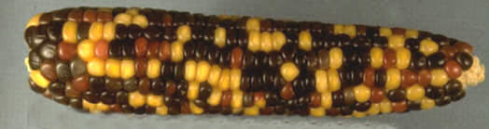

Corn also has really strange genes that jump around in a cell inactivating other genes and mucking with the colors of the kernels in really nifty ways:

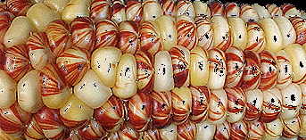 | 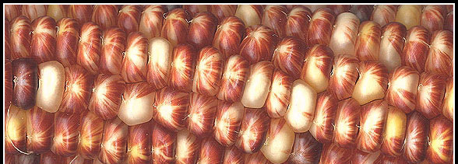
1 - Korn is also weird, but that’s a different topic.
2 – we would not have offspring if we would “keep them separated”
While those jumping genes are really exciting, they mess with the colors that are expressed in Mendelian genetics. The whole point of this lab is to learn about phenotypes, genotypes and Mendelian genetics, so for now we’ll just pretend that the nifty jumping genes don’t exist. What that means for you is that as you are counting kernels of corn and you find a striped kernel, skip it; do not count the striped ones as you figure out ratios.

In the cross of a purple heterozygote (Aa) and yellow (aa) you would expect a 1:1 phenotypic ratio in their offspring. Fill out this punnet square to show why

Dominant | Recessive`
Purple | Yellow
Red | White

The 1:1 ratio means that 50% of the offspring should be purple, and 50% should be yellow. If we looked at 100 kernels on an ear of corn, we would EXPECT 50 of the kenels on the ear to be purple and 50 of the kernels to be yellow.

A researcher counted the colors of corn kernels, and what she actually OBSERVED was 55 purple kernels and 45 yellow kernels. Obviously, the ratio she observed did not perfectly match the ratio that she would have expected based on the punnett square. In science, we often make predictions, and then test those predictions by observing results. When we compare our observations with the predictions (what we expect) and they are similar, we consider it to be evidence that those predictions could be correct. . If the data is very different from the predictions, we’ll know that we have NOT confirmed them, and something else must be happening.

One way to do this comparison is to use a statistical test called a chi squared analysis. First we need to calculate the value of Chi Squared:

 |  |  | (Observed - Predicted) | (Difference² ÷ Predicted)
Description | # Predicted | # Observed | Difference | Subtotals
Purple | 50 | 55 | 5 | 25/50=.5
yellow | 50 | 45 | -5 | 25/50=.5
 |  |  | Chi Squared =Total = | 1.0
Now determine if her chi square value is a good fit with her data. Your degrees of freedom (df) is the number of possible phenotypes minus 1. In this case, 2 - 1 = 1. Find the number in that row that is closest to your chi square value. Circle that number the number(s) that most closely match your chi squared value.
Good Fit Between Ear & Data |  |  |  |  |  |  | Poor Fit
df | .90 | .70 | .60 | .50 | .20 | .10 | .05 | .01
1 | .02 | .15 | .31 | .46 | 1.64 | 2.71 | 3.85 | 6.64
The number of our chi squared total (1.0) is between 0.46 and 1.64. This means that we are between 50% sure and 20% sure that the results we observed are due to the prediction being correct.
What would happen if the same researcher looked at a much larger sample? Suppose the she counted and recorded the color for 1000 kernels of corn. Let’s say that she looked at the offspring from a cross of two plants that were both heterozygous (Cc) for the red/white gene. In this cross, she would predict a 3 red: 1 white ratio for the kernels. Fill out this punnet square to show why

Dominant | Recessive`
Purple | Yellow
Red | White

How many red kernels should she expect to see? ________________

How many white kernels should she expect to see? _______________

What our researcher actually OBSERVED was 746 red kernels and 254 white kernels. Use this information to calculate her chi squared value

 |  |  | (Observed - Predicted) | (Difference² ÷ Predicted)
Description | # Predicted | # Observed | Difference | Subtotals
Red |  | 746
White |  | 254
 |  |  | Chi Squared =Total =

Now determine if her chi square value is a good fit with her data. Your degrees of freedom (df) is the number of possible phenotypes minus 1. In this case, 2 - 1 = 1. Find the number in that row that is closest to your chi square value. Circle that number the number(s) that most closely match your chi squared value.
Good Fit Between Ear & Data |  |  |  |  |  |  | Poor Fit
df | .90 | .70 | .60 | .50 | .20 | .10 | .05 | .01
1 | .02 | .15 | .31 | .46 | 1.64 | 2.71 | 3.85 | 6.64

The larger sample size and smaller percentage difference from the expected values means that this set of observations is a better fit to our predictions. How confident can we be about this experiment?

Confidence level between ____________________ and ____________________

In a dihybrid cross, we look at two different genes in the same cross. What phenotypic ratio of offspring (kernels) expect for a breeding between parents who are both heterozygous for color (Cc) and heterozygous for flavor (Ss)?
__________________________________
Fill out the punnett square to show why

Dominant | Recessive`
starchy | sweet
Red | White

Suppose you looked at 1600 kernels of corn. How many would you expect for each of these kernel phenotypes?
Starchy Red:_______ Starchy White:_______ Sweet Red:_______ Sweet White:_______

Now suppose that the numbers you actually observed were:
890 Starchy Red, 310 Starchy white, 295 sweet red, 301 sweet white
Use that information to calculate a chi squared value

 |  |  | (Observed - Predicted) | (Difference² ÷ Predicted)
Description | # Predicted | # Observed | Difference | Subtotals
Starchy Red |  | 890
Starchy White |  | 310
sweet red |  | 295
sweet white |  | 101
 |  |  | Chi Squared =Total =

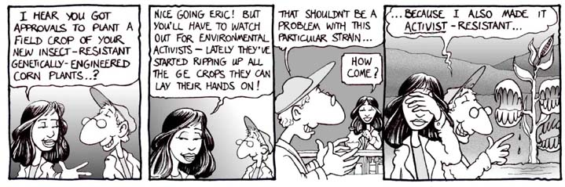
Now determine if your chi square value is a good fit with your data. Your degrees of freedom (df) is the number of possible phenotypes minus 1. In your case, 4 - 1 = 3. Find the number in that row that is closest to your chi square value. Circle that number.
Good Fit Between Ear & Data |  |  |  |  |  |  | Poor Fit
df | .90 | .70 | .60 | .50 | .20 | .10 | .05 | .01
1 | .02 | .15 | .31 | .46 | 1.64 | 2.71 | 3.85 | 6.64
2 | .21 | .71 | 1.05 | 1.39 | 3.22 | 4.60 | 5.99 | 9.21
3 | .58 | 1.42 | 1.85 | 2.37 | 4.64 | 6.25 | 7.82 | 11.34
4 | 1.06 | 2.20 | 2.78 | 3.36 | 5.99 | 7.78 | 9.49 | 13.28
Explain what it means to have a "good fit" or a "poor fit". Does yourhttp://www.vectortemplates.com/raster/batman-logo.gif chi square analysis of real corn data support the hypothesis that the parental generation was CcSs x CcSs?

Counting Phenotypes
This is a picture of a cross between two red corn plants that are both heterozygous (Cc).
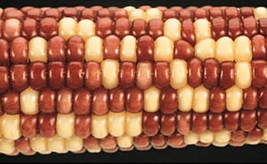
What would you expect the phenotypic ratio of the kernels to be?

_____________ to _____________
Red white

Count 100 kernels on this picture, and record the phenotypes (and their amounts) that you observe.

Phenotype | number
Red

White

Now calculate the chi squared value for your data

 |  |  | (Observed - Predicted) | (Difference² ÷ Predicted)
Description | # Predicted | # Observed | Difference | Subtotals
Red
White
 |  |  | Chi Squared =Total =

How many degrees of freedom are there in your data set?

Good Fit Between Ear & Data |  |  |  |  |  |  | Poor Fit
df | .90 | .70 | .60 | .50 | .20 | .10 | .05 | .01
1 | .02 | .15 | .31 | .46 | 1.64 | 2.71 | 3.85 | 6.64
2 | .21 | .71 | 1.05 | 1.39 | 3.22 | 4.60 | 5.99 | 9.21
3 | .58 | 1.42 | 1.85 | 2.37 | 4.64 | 6.25 | 7.82 | 11.34
4 | 1.06 | 2.20 | 2.78 | 3.36 | 5.99 | 7.78 | 9.49 | 13.28

Circle the row the number in the first column of the row that you should use for this table. Now circle the number(s) on that row that best describe the level of confidence you should have in the results of your data.

Approximately how sure are you that the things you observed matched your predictions?

Batman understands statistics!!!

