Photosynthesis

Concepts to understand:
Wavelengths of light and their energy levels
Photosynthesis: gasses used and generated
Respiration: gasses used and generated
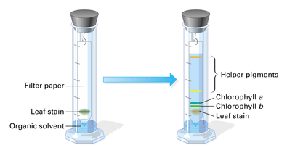
Fluorescence
Absorption and negative colors
Plant pigments
Chromatography

Things to watch or do
1. Classroom demo
Spectroscope
Color filters
Chlorophyll fluorescence
2. Paper chromatography
Water soluble ink
Plant extract
3. Rates of photosynthesis and respiration (oxygen levels)

Classroom Demo: Spectroscope

What colors of light are most useful to plants doing photosynthesis?

Which colors are NOT used?

Why do plants look green?

Plants contain several different pigments. Each one absorbs light in a slightly different frequency.

Do color filters CHANGE the color of the light they transmit?

What does a color filter do?

Which color of light is being transmitted by the chlorophyll extract?

Which colors are being absorbed?

What color does chlorophyll look when it is exposed to a black light?

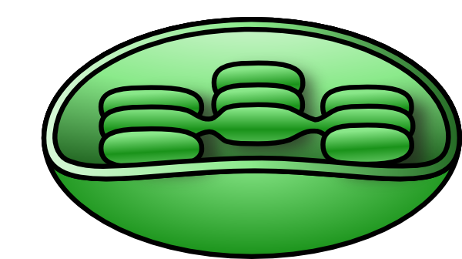
What process is happening when chlorophyll is exposed to a black light?

Why does this happen?
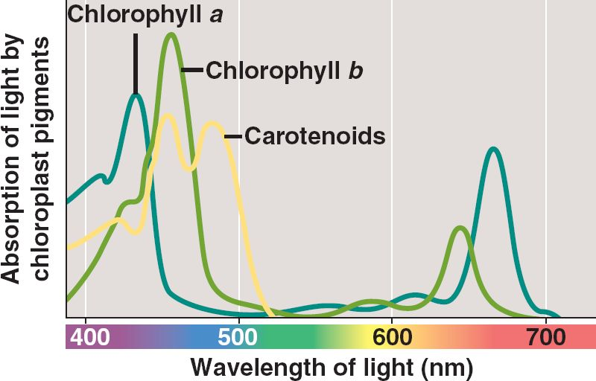

Paper Chromatography

Most chloroplasts contain four or more pigments. The chlorophyll extract appear green, but it is actually a mixture of colors because of the different pigments. You will now use paper chromatography to separate the pigment molecules of the extract by size and solubility. You will also separate the pigment molecules of water soluble ink. The ink will have bigger differences in the colors, making it easier to see the different pigments, and thus, will help you to understand pigment separation. This will help you know what to look for in your plant pigment separation.

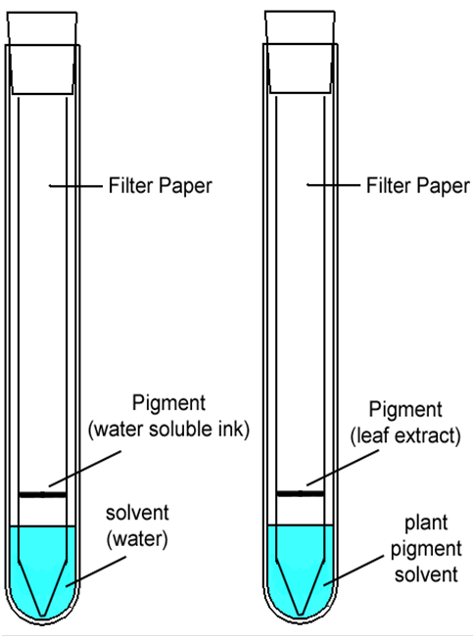
Methodology

- Obtain two strips of chromatography paper. Handle the strips as little as possible, and along the edges. Skin oils can interfere with the test.
- For both strips, fold the paper and cut a point onto the tip
- Draw a faint pencil line across the pointed end of the paper, about 1.5 inches from the tip
For paper with water soluble ink
  - Cover the pencil line with line from a water soluble marker. Do this at least five times on each side.
  - Hold your paper up to the test tube and make a mark on the tube at the level of the line
  - Put a little water in the bottom of the tube; enough to go about half way between the bottom of the test tube and the line.
  - Insert the paper strip with the water soluble ink line into this tube so that the tip of the paper is in the water, but the water is below the ink line.
  - Hold the paper in place as you insert a stopper into the top to keep the paper from falling.

For paper with pigment extract
  - Use a thin capillary tube to apply spinach pigment extract to the pencil line. Pull your extract from the BOTTOM of the vial so you get lots of the solids. Let the line dry thoroughly. DO THIS 15 TIMES!!!
  - Pour your vial of plant pigment solvent into the bottom of the test tube. Try not to get it on the sides of the tube.
  - Insert your paper strip with plant extract into the tube so that the tip of the paper is in the solvent, but the line with is above the top of the solvent.
  - Hold the paper in place as you insert a stopper into the top of the tube to keep the paper from falling.

- For both tubes, watch as the solvent line climbs up the paper. We call this line the “solvent front”. When the solvent front nears the stopper, remove the paper strip from the tube and let it air dry. When it is mostly dry, you should use a pencil to mark the UPPER MOST (furthest!!!) spot on the paper for each of the pigments AND mark the solvent front.
- You are now done with the paper containing water soluble ink. Set it aside so you can look at it later.

- For the plant pigment paper strip, try to find the following plant pigments.
Color pigment
Blue-green chlorophyll a
Yellow-green chlorophyll b
Light yellow xanthophylles
Bright yellow-orange carotenes
Grey phaeophytins (use black light. Hard to find)

SPINACH MAY HAVE MORE THAN ONE TYPE OF XANTHOPHYLL

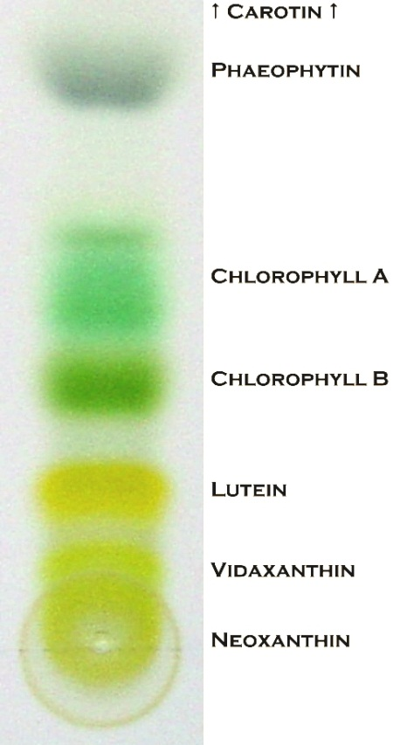
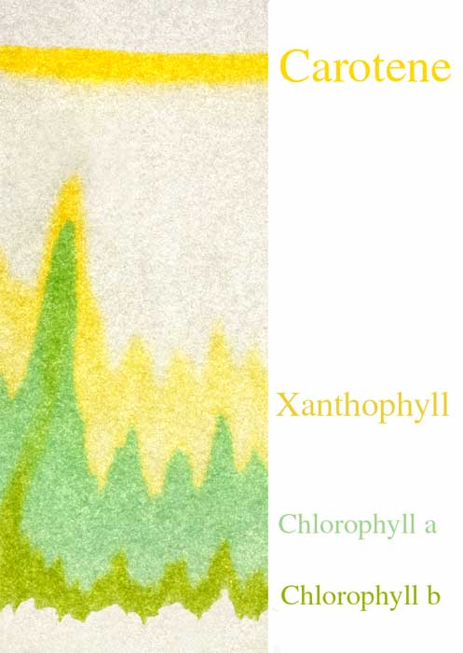
Chromatography Results:
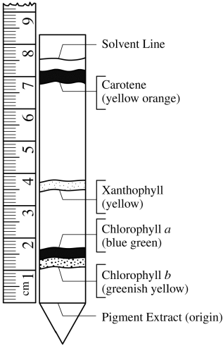

- For each pigment that you find, label the mark you made in step 4
- Measure the distance in mm from your original line (i.e. the line where the pigment started) to the labeled marks from step 7. Next to each mark, record the distance from the starting point that each pigment traveled.
- Measure and record the distance (in mm) from the starting pigment line to the solvent front line:

Solvent Front Distance (SFD) __________
- Fill out the chart below (Yes, there is math)

Pigment | Distance | ÷ | SFD | = RF
Chlorophyll a |  | ÷ |  | =
Chlorophyll b |  | ÷ |  | =
Xanthophylles |  | ÷ |  | =
Phaeophytins |  | ÷ |  | =
Carotinoids |  | ÷ |  | =

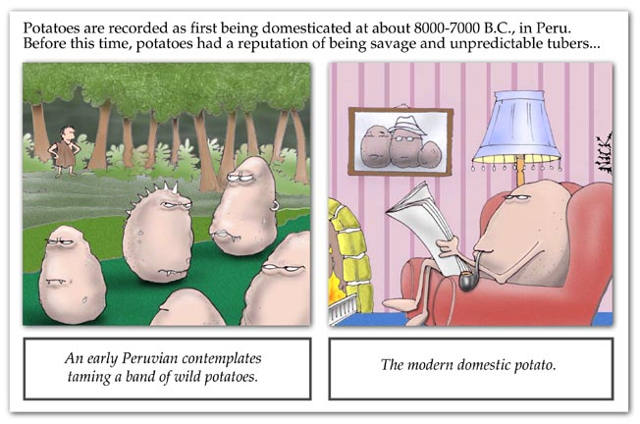

Photosynthesis and respiration
(as measured by oxygen production and use)

As part of the light reactions, water is split apart releasing oxygen. As part of cellular respiration, oxygen is used up in the mitochondria. You can measure these processes by using some fresh Elodea (a water plant) in a test tube filled with sodium bicarbonate.

- Fill a beaker with water at the sink. Push a flask into the beaker, letting the extra water run out into the sink. Fill the flask with water, then push the large test tube down into the flask so the water runs out of the flask. You now have a double water bath like the one shown below. This water bath will absorb heat from a light bulb preventing it from cooking and killing the Elodea in the tube.
- Remove the tube from the flask. Partially fill the tube with sodium bicarbonate solution which puts carbon dioxide into water
- Add two or three freshly cut sprigs of Elodea to the tube. Finish filling it with sodium bicarbonate solution The solution
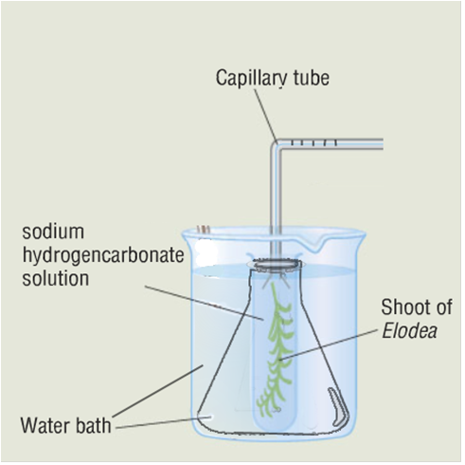
- Insert stopper with bent glass tube into test tube. Make sure that the bicarbonate solution goes up the bent tube until it is near the MIDDLE of the horizontal part.
- Use a marker or wax pencil to make a mark on the bent glass tube showing where the edge of the solution is.
- As soon as the solution front starts to move, time it for ten minutes.
- At the end of ten minutes, mark the new solution front location.

How far has it moved in the light?

What chemical is being taken out of the solution by plants doing photosynthesis?

What chemical is being produced by plants doing photosynthesis?
(hint: see next page)
Carefully pick up your equipment and put it into the dark cabinet under your lab table. DO NOT BUMP THE TUBE WHEN DOING THIS!!!!
After 10 minutes in the dark, mark new solution front location.

How far has it moved in the dark?
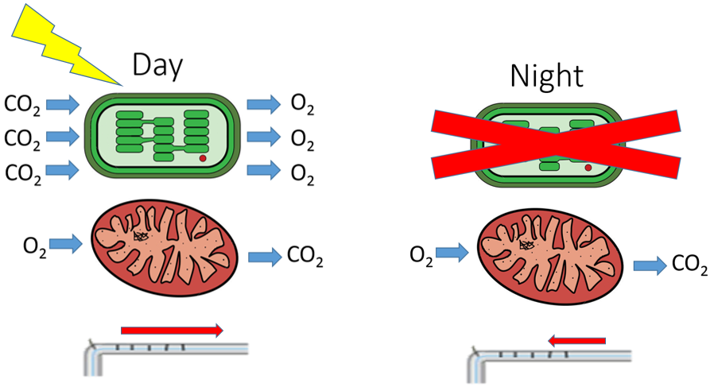

Remember that in the dark the plant will use oxygen for respiration but will not do photosynthesis. In the light, the plant is doing both photosynthesis and cellular respiration, but it does a LOT more photosynthesis. If we want to determine the total amount of oxygen that produced, we add these two values together.

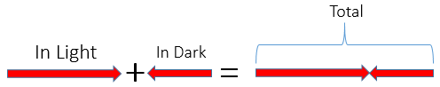

Net oxygen in the light:

Oxygen used in dark:

Total Oxygen Produced:

Carbon Dioxide combines with water to form carbonic acid. The pH of e water in a shallow pond with lots of aquatic plants and algae can change depending on the time of day.

What chemical is taken out of the water during the day when lots of photosynthesis is happening?

What does this do to the pH of the pond’s water?

CO₂

What chemical is being put into the water at night?

What does this do to the pH of the pond’s water?

