Microscope and Cells

Things to do in this lab
Microscope
- Overview: light and electron microscopes
- Discussion: How to use a microscope
- Use the Microscope

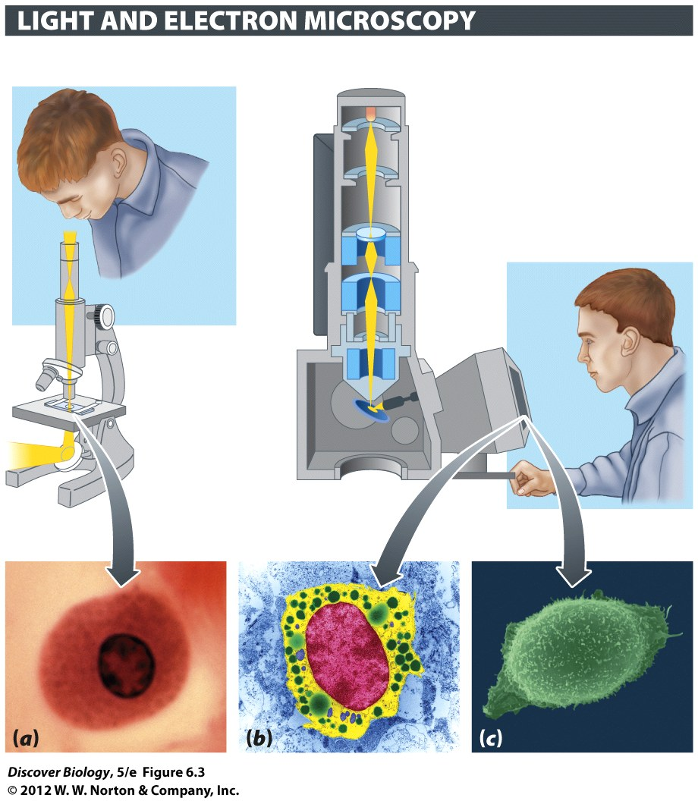

Complete the comparison chart

 | Light microscope | Electron microscope
Beam of energy
lenses are made of
How to focus

Using the terms listed below, label the microscope diagram

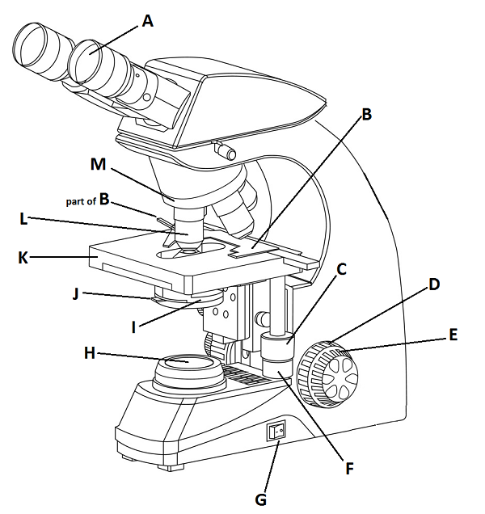
A. ______________________________ B. ______________________________

C. ______________________________

D. ______________________________

E. ______________________________

F. ______________________________

G. ______________________________

H. ______________________________

I. ______________________________

J. ______________________________

K. ______________________________

L. ______________________________

M. ______________________________

coarse focus knob - a knob that makes large adjustments to the focus.
diaphragm - an adjustable opening in the condenser stage, usually controlled by a tab
ocular lens - where you place your eye.
fine focus knob - a knob that makes small adjustments to the focus (it is usually smaller than the coarse focus knob).
inclination joint - an adjustable joint that lets the arm tilt at various angles.
objective lens - a small lens on nosepiece. You change magnification by changing objective
mirror (or light source) - this directs light upwards onto the slide.
revolving nosepiece - the rotating device that holds the objectives (lenses).
stage - the platform on which a slide is placed.
light – illuminates specimen.
Power button – turns microscope on and off.
Condenser – gathers light and focuses it into a cone that illuminates specimen
slide holder – Has two parts, uses spring tension to hold slide securely.
Y axis knob – moves entire stage forward and back (see my video)
X axis knob – moves slide holder to left and right (see my video)
Tips For Using your Microscope

- Make sure your light is turned up to full power and your iris/aperture is completely open. The majority of the time when students say their microscope is broken, one of these two settings is wrong. As you start to use the microscope, you may – especially at low power – choose to turn down the light. That’s OK, but always start with it wide open.
- Put your slide in the slide holder of the stage. If you don’t do this, it will be difficult to move the slide small amounts.
- Always start by using the low power objective. Many people call this a “scanning” objective because it allows to scan the slide quickly and find things that might be interesting at higher magnifications. This lower power/scan is the best way to find things; if you try to find things with a higher magnification you will probably be frustrated. DO NOT TRY TO USE HIGHER POWER OBJECTIVES IF YOU HAVE NOT FOUND THE ITEM WITH THE SCANNING OBJECTIVE
- Do your initial focusing with the coarse focus knob
- Higher magnifications need higher more light. If you move to a more powerful objective, you will need to increase the light
- When you go to higher power, you will need to refocus. Try to do this with the fine focus knob. That is usually faster and easier than using the coarse focus knob.

Things to do with your microscope in this lab
- Look at the letter ‘e’. Notice the way the letter looks on your microscope slide, and the way it is flipped in the microscope. Remember to start on low power, then move to a higher power so you can see the fibers in the paper or dots in the ink
- Look at crossed threads under high magnification. Remember to start on low power, then move up. You will need to refocus each time you go up in magnification. This is best to do with the fine focus knob.
- Look at something alive. We have pond water and several commercial cultures of microbes. Sometimes we have a small insect. It is good practice to try moving the microscope stage to keep these things in view as they swim around.

Calculate your microscope’s magnification
Objective Lens | magnification | Ocular | Total Magnification
Scanning |  | X 10 | =
medium |  | X 10 | =
High power (for dry) |  | X 10 | =
Oil Immersion |  | X 10 | =

