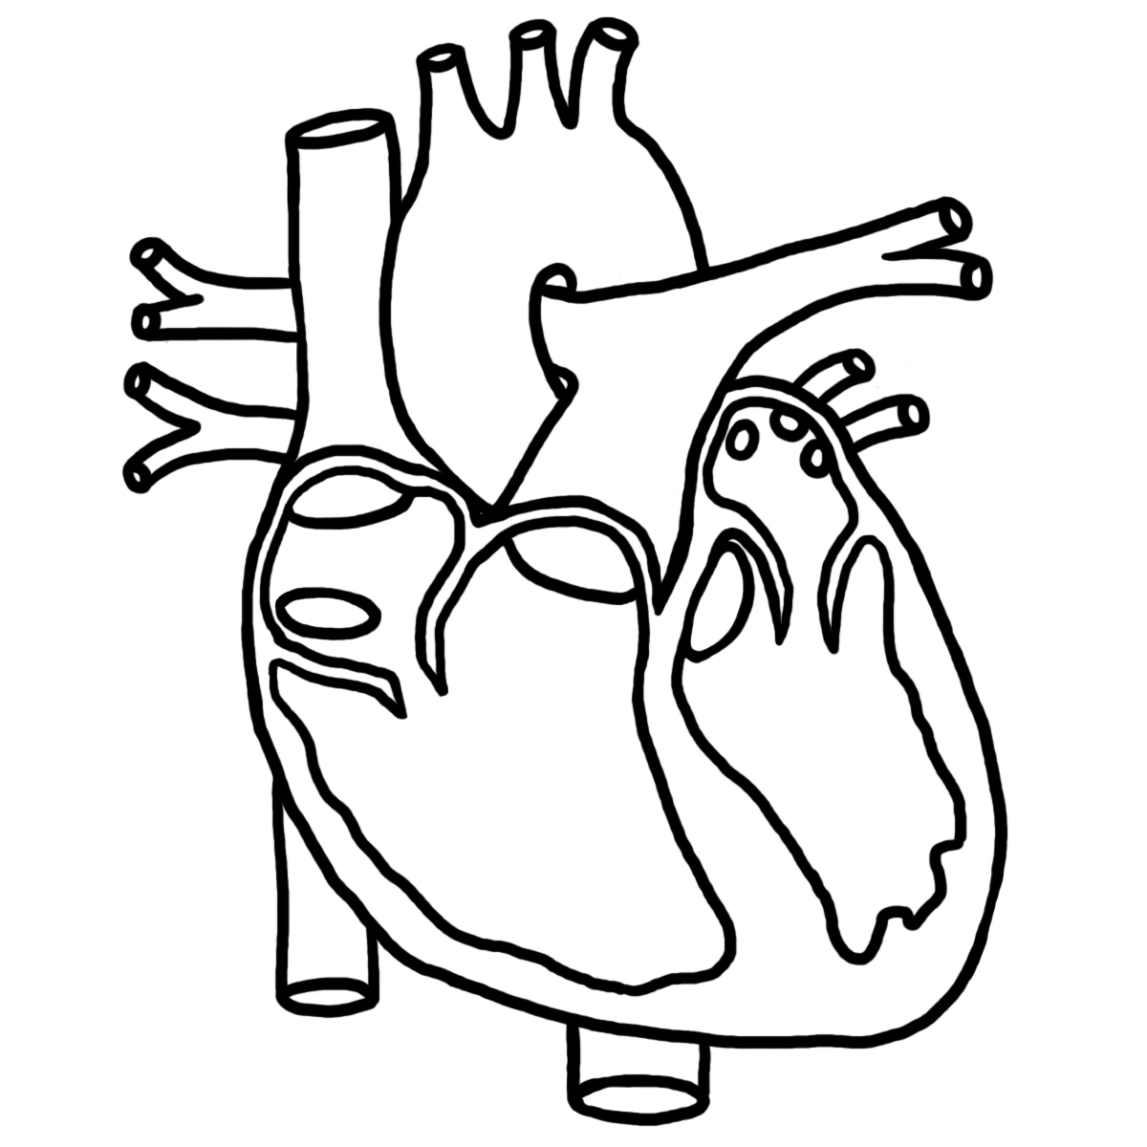 | BSC 2086C Fall 2013  Anatomy and Physiology II  Tentative Syllabus and Rules  Instructor Information  Joseph Maier Office: WSC 116  Email: jmaier@polk.edu Office Phone: 863-298-6894

When and where each section should meet:
Number Lecture Lab
47897 Fri: 9:00 AM – 11:50 AM (WSC 131) Fri: 12:00 PM – 1:50 PM (WSC 127)
47893 Tues-Thurs: 1:30 PM – 2:45 PM (WSC 131) Tues: 11:30 AM – 1:20 PM (WSC 127)
47896 Mon-Wed: 3:00 PM – 4:15 PM (WSC 131) Wed: 4:30 PM – 6:20 PM (WSC 127)
Note: Please attend your designated class time!

Welcome to Survey of Biology
This course is a one semester general overview of biology fulfills the laboratory component of the Natural Science
General Education requirement for non-science majors. The goal of this course is to help you develop an understanding
of the unifying principles that govern life. Assessment will be based on tests, quizzes, laboratory reportss and handouts,
participation, attendance and a film review paper. These grading criteria are explained in detail later in this document.

Basic Course Information Sheet (BCI)
A Basic Course Information sheet containing official course description and objectives is available on the College website
(under current students) and on the PAL page for your course.

Dates To Remember
Last Day to Drop with 100% Refund: Friday, August 23, 2013
Days Off: Labor Day Holiday: (Monday, September 02, 2013), Thanksgiving Break (Wed-Sun, 11/27/2013-12/01/2013)
Last Day for withdrawal: Friday, November 01, 2013
Final Grades Due: Thursday, December 12, 2013 at 9:00 AM

Required Textbooks and Materials
1. Human Anatomy and Physiology, 9th Edition. Marieb, Elaine N. and Hoehn, Katja N., W.W. Benjamin-Cummings Publishing Company. Available at the PSC bookstore.
2. Human Anatomy & Physiology Laboratory Manual, Fetal Pig Version, Update (10th Edition), Benjamin-Cummings Publishing Company. Available at the PSC bookstore.
How To Contact Me
You are welcome to email or call me using the information at the start of this syllabus, but do not expect an immediate response. During the week, this often takes 24-36 hours. It can take longer during the weekend. If you require a more rapid response, the best method is to meet with me face to face. Asking questions before or after class is usually effective. You can also meet with me during my scheduled office hours, or arrange a meeting time outside those hours. My office hours are listed in PAL.

This Syllabus is Tentative
All the contents of this syllabus are subject to change. This includes, but is not limited to, the dates of labs, lectures, tests and assignments. It may also include class rules, the grading criteria or weighting of grades. While every effort will be made to avoid changes, you should be aware of the possibility. If you are uncomfortable with changes being made during the semester, or you have difficulty adapting your schedule to these types of changes, you should strongly consider taking this course from a different instructor.
Course Rules
There are a few simple rules that I ask you to follow.

1. Submit Work by the Due Date
Most assignments and quizzes cannot be made up and makeups will only be considered in extenuating circumstances. All assignments have due dates that must be met. FAILURE TO SUBMIT AN ASSIGNMENT BY THE DUE DATE WILL SIGNIFICANTLY ALTER YOUR GRADE. Suppose that you have a lab handout worth 10 points:
- Turning the work in the one period after it was due will result in an an automatic reduction of 30% (e.g. 7/10 as the maximum score).
- Turning an assignment in two class periods after it was due will result in an automatic reduction of 50% (e.g. 5/10 as the maximum score)
- Turning in the work three periods or more after it was due will result in an automatic zero
NO ASSIGNMENTS WILL BE ACCEPTED AFTER GRADES ARE POSTED

If your class has online quizzes, they must be completed ON TIME. If a quiz has a due date listed in the PAL calendar, you must complete the quiz before the due date; the quiz will not be available after that date. Students who do not complete the quizzes before they expire will have a zero recorded as the grade for that quiz.

2. Be On Time
Arriving late and leaving early are completely unacceptable. If you are tardy (or leave early) you will miss activities and
other assignments and will not receive credit for them. Tardiness or leaving a class early will count as half an absence.

3. Be Ready To Learn
You should come to class having completed all assigned reading and homework. You should also be prepared to actively
participate in the class. Active participation means taking part in activities, taking notes, and contributing to class
discussions.

4. Come to Class
Attendance is mandatory. Your success is dependent upon you attending every class and actively participating in it. If
you are absent you will miss important information and loose participation points. If you should have a medical or
family emergency please let me know as I am willing to try and work around these occurrences given that you are able
to provide proper documentation. Please note that you may be dropped for missing all or part of four or more classes.
If you are dropped before the withdrawal date you will receive a W. If you are dropped after the withdrawal date you
will receive an F. (Please see “Dates To Remember” on the first page”.) Also note that it is not the instructor’s
responsibility to drop a student who entirely stops coming to class; this is the responsibility of the student.

5. Turn Off Cell Phones and Electronics
Using phones, tablets, computers and text messaging devices during class is not allowed. These devices must be turned off and put away. A cell phone ringing or even vibrating during class is unacceptable.

6. Respect Your Classmates
You must treat your peers with respect. This means you will listen attentively while they are speaking and allow them to freely express their thoughts and ideas, even on controversial subjects where you may disagree. A positive environment must be maintained in the classroom as we discuss things from a scientific point of view.

7. Stay in the classroom after you have entered
Unless you have a medical condition that makes it impossible to do so, please deal with your bathroom, food or drink needs BEFORE the start of class so you don’t need to enter and exit the room. Wandering in and out of the room may result in an absence for the day.

8. Participate in the conversation, but don’t monopolize it. Asking questions in class is a great way to enhance your understanding of the information. If you don’t understand something, there’s a good chance that several other students have the same questions that you do. By asking in class, you make sure that everyone gets that information.

9. Follow Guidelines for Assignments
Pay close attention to the guidelines for all assignments. Make sure to read the descriptions and review any supplemental information on the PAL course website. Written work should be typed in a 12 point New Times Roman font and double spaced unless otherwise specified. Pages should be formatted with standard one-inch margins. Please strive to avoid grammatical and spelling errors. It is usually a good idea to proofread your work several times before submitting it. In addition, you should cite any sources that you consulted or took information from when completing written assignments. Grading criteria may include spelling and grammar on some assignments.

10. Don’t Cheat or Plagiarize
Plagiarism of written or oral work is prohibited and will not be tolerated. This includes but is not limited to: using information or quotations without proper citation, directly copying all or parts of speeches or papers, or submitting someone else’s work as your own. Cheating is also prohibited and will not be tolerated. This includes but is not limited to: cheating on quizzes or tests, signing anyone’s name other than your own for attendance or participation purposes, or sharing answers on activities that are intended to assess an individual’s knowledge. Penalties for plagerism or cheating may include receiving an F on the assignment, receiving and F in the course, or other disciplinary action as determined by the college. Please consult the Polk State College Student Handbook and Catalog for more information about the college’s cheating and plagiarism policy.

11. Ask Questions
Please ask me if f you don’t understand something, want clarification about an assignment or topic we discussed in class, or need additional help. I anticipate that you’ll have many questions during the semester. I’m always happy to help! Feel free to stop by during office hours, or to email me. During the week, I try to answer emails within 24 hours. On the weekend, it may take a little longer.

12. Request any necessary accommodations
If you require an accommodation due to a physical or learning impairment please contact Student Services. To communicate with a special needs advisor, please call (863) 297 – 1010, extension 6110 in Lakeland or extension 5227 in Winter Haven. Creating a class that is accessible and comfortable for everyone is important. I am happy to make accommodations necessary to facilitate your success in this class.

Grading
% of grade Point Value
 | Percent of Grade | Number of Points | Grading Scale
Lecture Tests 6 | 60% | 600 | 100 - 90% = A = 900 points or more
Lab Assignments | 30% | 300 | 89 - 80% = B = 800 points or more
Online quizzes | 10% | 100 | 79 - 70% = C = 700 points or more
 |  |  | 69 - 60% = D = 600 points or more
 |  |  | 59% or less = F = 500 points or more
 |  |  | Total Possible 100% 1000 points

DO NOT CONTACT ME BY EMAIL OR PHONE TO ASK ABOUT YOUR GRADE. I ONLY DISCUSS GRADES FACE TO FACE. THIS ALLOWS ME TO VERIFY THE IDENTITY OF THE PERSON MAKING THE INQUIRY

Schedule
You will be given a tentative schedule for labs, lectures and tests. The dates may be changed during the semester.

Description of Assignments, Tests and Quizzes

Students are expected to complete ALL handouts, reports and assignments, and keep them in a portfolio or folder, and bring them to EVERY class or lab. This portfolio may be checked frequently.

Description of Assignments, Tests and Quizzes

Missed Test Policy
you are absent on the day of a lecture test, you may make arrangements with me to take the lecture test in the TLCC at a different time. Unless you have made special arrangements with me, you must take that test within the next week. If you are absent when a written assignment is due, you can email the document to me before the end of the due date.

Online Quizzes must be taken at the appointed time

THERE ARE NO MAKEUP LAB TESTS because of the time and effort needed to set up and tear down a test. If you are going to miss a test, your only option is to take the lab test of another instructor. You must make arrangements with myself and the other instructor before doing this.

Quizzes and Tests

Tests and quizzes may contain a variety of question types. Examples include multiple choice, short answer (essay), fill in
the blank, and matching. Be prepared to take these on the date when they occur. If there are extenuating
circumstances, makeup lecture tests may be placed in the TLCC. If you are absent on the day of a lecture test, you may make arrangements with me to take the lecture test in the TLCC at a different time. You may drop one lecture test

Participation
Each student is expected to participate in class; i.e. pay attention and ask questions. If group work is assigned, they will
assist the group. Neither sleeping nor using your cell phone/computer in class resemble proper participation, and both may result in loosing participation points.

Laboratory Assignments, Reports and Handouts
Please consult your class’s PAL website before lab. Many of the laboratory handouts can be found there. Students are expect to print their own copies of any uploaded handouts prior to the start of each lab. Any questions on the handout should be answered by the student. Some handouts will require may include graphing, ratios, rate calculations and other mathematics.

Some labs may require reports which will probably need to complete as homework. The report should explain the goal of the lab, if anything was tested, what if any experimental results they found, and what their results demonstrate. Reports must be more than one paragraph and less than one page. The student will be responsible for keeping their reports.

